Flipkart Sales Data Analysis Dashboard
Project Overview
The Flipkart Sales Data Analysis Dashboard is an interactive Excel dashboard designed to analyze sales performance and generate actionable business insights from Flipkart's e-commerce sales data.
The dashboard provides a comprehensive view of key business metrics, enabling stakeholders to monitor sales trends, evaluate product performance, analyze seller contributions, and support data-driven business decisions.

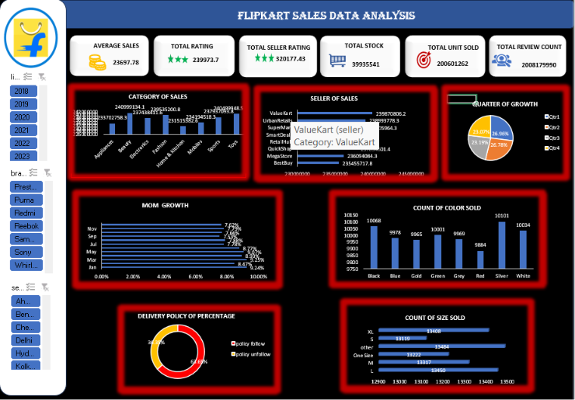
Business Objectives
The primary objectives of this dashboard are to:
- Monitor overall sales performance.
- Analyze Quarter-over-Quarter (QoQ) and Month-over-Month (MoM) sales growth.
- Measure delivery policy performance.
- Track product inventory and units sold.
- Identify high-performing products, sellers, and categories.
- Support strategic business decision-making through data analysis.

Key Performance Indicators (KPIs)
The dashboard tracks the following KPIs:
- Average Sales
- Total Ratings
- Total Seller Ratings
- Total Stock Available
- Total Units Sold
- Total Review Count

Dashboard Visualizations
The dashboard includes multiple interactive visualizations:
Visualization | Purpose
Column Chart | Displays sales by product category
Bar Chart | Shows seller-wise sales, MoM growth, and size-wise product sales
Pie Chart | Illustrates quarterly sales growth and delivery policy percentages
KPI Cards | Highlights important business metrics
Slicers | Enables interactive filtering of dashboard data

Filters (Slicers)
Users can filter the dashboard using:
- Year
- Brand
- Seller City

Tools & Technologies Used
- Microsoft Excel
- Pivot Tables
- Power Pivot
- XLOOKUP
- IF Function
- GETPIVOTDATA
- Charts & Dashboard Design

Business Insights
The analysis revealed several valuable insights:
- The Appliances category generated the highest sales.
- BestBuy was the top-performing seller based on total sales.
- January recorded the highest Month-over-Month (MoM) sales growth.
- The first quarter (Q1) showed the strongest sales performance.
- Products with Large (L) size and Black color were sold most frequently.
- The dashboard effectively tracks delivery policy performance and fulfillment percentages.
- Sales trends can be monitored across different brands, cities, and years.

Business Recommendations
Based on the analysis, the following recommendations are suggested:
- Increase inventory levels for high-demand products.
- Focus marketing efforts on both high-performing and underperforming cities.
- Launch promotional campaigns during low-sales months.
- Optimize pricing strategies for underperforming products.
- Strengthen partnerships with top-performing sellers.
- Continuously monitor customer reviews and ratings to improve product quality and customer satisfaction.

Expected Business Outcomes
Implementing the insights from this dashboard can help achieve:
- Faster and more informed decision-making
- Improved sales performance monitoring
- Better inventory management
- Increased operational efficiency
- Higher profitability
- Enhanced business performance through data-driven strategies

Project Features
- Interactive Excel Dashboard
- Dynamic KPI Cards
- Automated Data Analysis
- Sales Trend Analysis
- Seller Performance Analysis
- Category-wise Sales Analysis
- Inventory Monitoring
- Delivery Performance Tracking
- Interactive Filters for Better User Experience

Author
Amit Dhali
Aspiring Data Analyst
Skills: Excel | SQL | Python | Power BI | Tableau

